# CERTIFICATE OF COMPLETION

*This is to certify that the following participants:*

1. Nwokro Chidubem Jefferson
2. Chima Abone Joseph
3. Joseph Okechukwu

Have successfully completed the "Grafil ATM Project" on the 31st day of October, 2023.

Project Description:

The "Grafil ATM Project" involved the design and development of an Automated Teller Machine (ATM) system, aimed at automating financial transactions and improving user experiences in banking. The project included the creation of both Admin and User modules, as well as various features such as account creation, deposit, withdrawal, balance inquiry, password change, and transaction reporting.

Congratulations to the participants for their dedication and successful completion of this project.

[Team Name] [Date]

GRAFIL ATM PROJ [30/10/2023]

# TABLE OF CONTENT

### Certificate of Completion (page 1)

* + Project Participants
  + Project Description
  + [Signature] [Your Name]
  + [Your Title/Position]
  + [Date: 31/10/2023]

### Problem Definition of the Grafil ATM Project (page 4)

* + Challenges in Manual Banking Processes

### Customer Requirement Specification (CRS) for Automated Teller Machine (ATM) System (pages 5-7)

* Introduction
* Existing Scenario
* Proposed Solution
* Functional Requirements
* Admin
* User
* Reports
* Conclusion

### Project Plan: Automated Teller Machine (ATM) System --- (pages 9 – 12)

* + Project Overview
  + Proj

ect Objectives

* + Project Phases
  + Resources
  + Risk Assessment
  + Project Deliverables
  + Milestones
  + Dependencies
  + Communication Plan

### Project Review and Monitoring Report (pages 13 – 16)

* + - Executive Summary
    - Project Objectives
    - Project Review
    - Project Phases and Milestones
    - Achievements
    - Areas for Improvement
    - Conclusion

### Unit Testing Checklist for "Grafil ATM Project" (pages 17 – 19)

* + - * Introduction
      * Test Objectives
      * Unit Testing Scenarios
      * Admin Module
      * User Module
      * General
      * Test Execution
      * Test Completion
      * Conclusion

### Final Checklist for "Grafil ATM Project" (pages 20 – 22)

* + - * + Introduction
        + Project Documentation
        + Project Objectives
        + Project Deliverables
        + Project Review
        + General Review
        + Final Approval
        + Documentation and Handover
        + Archiving
        + Conclusion

Table of Contents

* Certificate of Completion
* Problem Definition of the Grafil ATM Project
* Customer Requirement Specification (CRS) for (ATM) System
* Project Plan: Automated Teller Machine (ATM) System
* Project Review/Monitoring
* Unit Testing Checklist
* Final Checklist

# Problem Definition of the Grafil ATM Project

The problem that the "Grafil ATM Project" seeks to address is the inefficiency, inaccuracy, and resource-intensive nature of traditional manual banking processes. Prior to the implementation of this project, the financial institution relied on cumbersome manual methods for conducting various banking transactions, which resulted in several issues and challenges:

1. Manual Transaction Processing: The existing manual system required bank employees to manually handle and record each customer transaction, leading to an increased workload for the bank staff.
2. Data Discrepancies: Manual data entry and processing were prone to human errors, leading to discrepancies in financial records and account balances. These errors could lead to customer dissatisfaction and operational inefficiencies.
3. Limited Accessibility: Customers had to visit the bank during specific operating hours to access their accounts and conduct transactions. This limited accessibility to banking services and inconvenienced customers.
4. Data Retrieval Challenges: Retrieving historical transaction data and generating reports for customers or regulatory purposes was a time-consuming and error-prone process in the manual system.
5. Security Concerns: Security vulnerabilities existed in the manual system, with the potential for unauthorized access to customer information and financial records.
6. Paperwork and Administrative Burden: The manual system required extensive paperwork for recording transactions, creating and managing customer accounts, and maintaining detailed financial records. This administrative overhead hindered operational efficiency and increased costs.

The "Grafil ATM Project" aims to address these problems by automating the banking processes through the development of an Automated Teller Machine (ATM) system. This system will provide a secure and convenient means for customers to access their accounts, conduct transactions, and obtain real-time financial information. By automating these processes, the project seeks to reduce errors, enhance security, improve customer satisfaction, and streamline the overall banking operations.

# Customer Requirement Specification (CRS) for Automated Teller Machine (ATM) System

1. Introduction

This Customer Requirement Specification (CRS) outlines the functional and non- functional requirements for the development of an Automated Teller Machine (ATM) system. The ATM system is intended to streamline banking transactions, enhance security, and provide a user-friendly experience for both administrators and users.

1. Existing Scenario

In the existing scenario, banking transactions are performed manually, leading to paperwork, maintenance challenges, data discrepancies, and time wastage. The ATM system aims to eliminate these issues by automating the process.

1. Proposed Solution

The proposed solution involves the creation of an ATM system with two modules: Admin and User. Admin will be responsible for creating user accounts and managing various reports. Users will have access to their accounts for performing transactions and managing their passwords.

1. Functional Requirements

## Admin

* Creating User Accounts: Admin can create user accounts by providing a unique identification number and a four-digit Personal Identification Number (PIN) along with basic details such as name, contact number, gender, and address.
* Transaction Verification: The system should enforce the following transaction limits:
* Deposit: Users can deposit a maximum of $25,000 in a single day and not more than 5 times a day.
* Withdrawal: Users can withdraw a maximum of $25,000 in a single day and not more than 5 times a day.

### Reports:

* Withdrawal Report: Generate a report of all withdrawal transactions for a specific date, including name, unique number, withdrawal amount, and balance.
* Deposit Report: Generate a report of all deposit transactions for a specific date, including name, unique number, deposited amount, and balance.
* Transfer Report: Generate a report of all transfer transactions for a specific date, including debitor's name, unique number, money transfer, and balance, and creditor's name, unique number, and balance.
* Account Report: Display a list of all registered users with details like name, unique identification number, contact number, gender, and age.
* Transaction Verification:

## User

* Deposit: Users can enter the amount they want to deposit and confirm by clicking an "Enter" button.
* Withdrawal: Users can enter the amount they want to withdraw and confirm by clicking an "Enter" button. Invalid balance messages should be displayed for insufficient funds.
* Balance Enquiry: Display the user's available balance.
* Change Password: Allow users to change/reset their passwords. Users need to provide their old password and the new password twice for confirmation.

### Reports

* Withdrawal Report: Display withdrawal transactions for a specific date, including name, unique number, withdrawal amount, and balance.
* Deposit Report: Display deposit transactions for a specific date, including name, unique number, deposited amount, and balance.
* Transfer Report: Display transfer transaction details for a specific date, including debtor’s name, unique number, money transfer, balance, creditor's name, unique number, and balance.
* Account Report: List all registered users with their details.

### Conclusion

This Customer Requirement Specification (CRS) outlines the requirements for the development of an ATM system. The system aims to automate banking transactions, provide enhanced security, and offer a user-friendly experience for administrators and users. Proper validation constraints will be implemented to ensure data accuracy and security.

# Project Plan: Automated Teller Machine (ATM) System

### Project Overview

Project Name: ATM System Implementation Project Start Date: [Start Date]

Project End Date: [End Date]

### Project Objectives

Develop and implement an automated ATM system to replace manual transaction processes.

Provide users with a secure and efficient banking experience. Improve data accuracy and reduce manual paperwork.

### Project Phases

1. Project Initiation (Week 1)
   * Define project scope and objectives.
   * Assemble project team.
   * Establish communication plan.
   * Define project timeline.
2. Requirements Analysis (Week 1)
   * Gather detailed requirements based on provided information.
   * Create a detailed functional specification document.
   * Review and finalize requirements with stakeholders.
3. System Design (Week 2)
   * Design the system architecture.
   * Develop the user interface and database schema.
   * Create wireframes and mockups for the user interface.
4. Development (Week 2)
   * Implement the admin and user modules.
   * Implement the user authentication process.
   * Develop validation constraints and security measures.
   * Create and integrate the database.
5. Testing (Week 3)
   * Perform unit testing, integration testing, and system testing.
   * Identify and resolve any issues or bugs.
   * Validate that the system meets the functional requirements.
6. Documentation (Week 3)
   * Create comprehensive documentation for the system.
   * Include user manuals, admin guides, and system architecture documentation.
7. Training (Week 3)
   * Provide training for admin users and support staff.
   * Ensure that users understand the system's features and functionality.
8. Pilot Testing (Week 4)
   * Deploy the system in a controlled environment for pilot testing.
   * Gather feedback from users and stakeholders.
   * Make any necessary adjustments based on feedback.
9. Deployment (Week 4)
   * Deploy the ATM system in production.
   * Monitor system performance and address any issues that may arise.
10. Project Closeout (Week 4)
    * Conduct a project review and evaluation.
    * Document lessons learned

Resources

* + Project Manager
  + Business Analyst
  + Developers
  + Quality Assurance Team
  + Training Instructors

Risk Assessment

* + Identify potential risks and develop mitigation strategies.

Project Deliverables

* + Fully functional ATM system.
  + Comprehensive system documentation.
  + Training materials.
  + Successful deployment in the production environment.

Milestones

* + Requirements analysis completed.
  + Development and testing phases completed.
  + Successful pilot testing.
  + Full deployment in production.

Dependencies

* + Availability of development and testing resources.
  + Timely feedback and approval from stakeholders.

Communication Plan

* + Regular project status updates to stakeholders.
  + Weekly team meetings to track progress.

# E – DIAGRAM

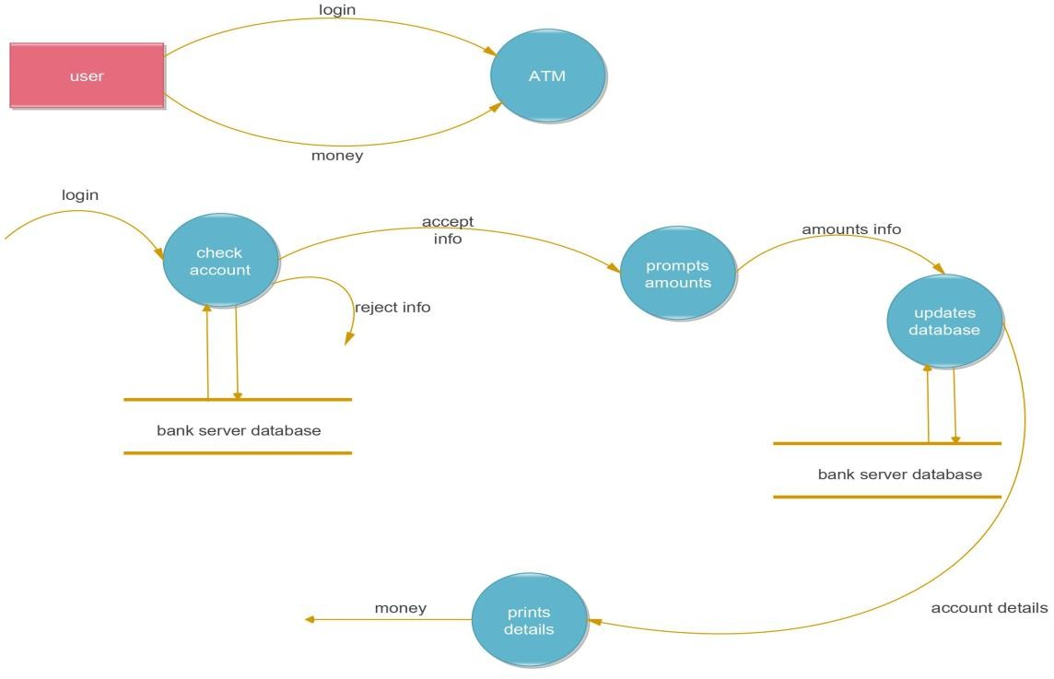

**Project Review and Monitoring Report**

Project Name: Grafil ATM Project Project Completion Date: [30/10/23]

Executive Summary

The "Grafil ATM Project" aimed to automate financial transactions and enhance the user experience in banking. The project successfully addressed several challenges associated with manual banking processes. This report provides an overview of the project's scope, objectives, achievements, and areas for improvement.

Project Objectives

* Develop and implement an Automated Teller Machine (ATM) system to replace manual transaction processes.
* Provide users with a secure and efficient banking experience.
* Improve data accuracy and reduce manual paperwork.

Project Review

Project Phases and Milestones

The project was structured into the following phases and milestones:

1. Project Initiation** (Week 1)

* Defined project scope and objectives.
* Assembled the project team.
* Established a communication plan.

1. Requirements Analysis (Week 1)

* Gathered detailed requirements based on provided information.
* Created a detailed functional specification document.
* Reviewed and finalized requirements with stakeholders.

1. System Design (Week 2)

* Designed the system architecture.
* Developed the user interface and database schema.
* Created wireframes and mockups for the user interface.

1. Development (Week 2)

* Implemented the admin and user modules.
* Implemented the user authentication process.
* Developed validation constraints and security measures.
* Created and integrated the database.

1. Testing (Week 3)

* Performed unit testing, integration testing, and system testing.
* Identified and resolved issues or bugs.
* Validated that the system met functional requirements.

1. Documentation (Week 3)

- Created comprehensive documentation for the system, including user manuals, admin guides, and system architecture documentation.

1. Training (Week 3)

* Provided training for admin users and support staff.
* Ensured that users understood the system's features and functionality.

1. Pilot Testing (Week 4)

* Deployed the system in a controlled environment for pilot testing.
* Gathered feedback from users and stakeholders.
* Made necessary adjustments based on feedback.

1. Deployment (Week 4)

* Deployed the ATM system in production.
* Monitored system performance and addressed any issues that arose.

1. Project Closeout (Week 4)

* Conducted a project review and evaluation.
* Documented lessons learned.

Achievements

The "Grafil ATM Project" achieved the following key outcomes:

* + Successful automation of financial transactions, reducing manual workload.
  + Improved data accuracy, reducing discrepancies in financial records.
  + Enhanced security through the automated system.
  + Increased accessibility to banking services, improving user satisfaction.
  + Streamlined administrative processes, reducing paperwork and operational inefficiencies.

### Areas for Improvement

While the project achieved its objectives, there are areas where further improvement can be considered:

* + Continuous monitoring and maintenance of the ATM system to ensure its reliability.
  + Regular updates to the system to incorporate new features or address emerging security challenges.
  + A clear strategy for long-term archiving and storage of project documentation.

### Conclusion

The "Grafil ATM Project" successfully addressed the challenges associated with manual banking processes by automating financial transactions. The project not only improved data accuracy and security but also enhanced user satisfaction. Continuous monitoring and maintenance will be essential to ensure the long-term success of the ATM system.

[Team Name] [Date]

GRAFIL ATM PROJ [30/10/2023]

# Unit Testing Checklist for "Grafil ATM Project"

Project Name: Grafil ATM Project Unit Testing Date: [29/10/23]

Introduction

Unit testing is a critical phase of the "Grafil ATM Project," ensuring that individual components of the system function as expected. This checklist provides guidance for conducting unit testing to validate the functionality and accuracy of the project components.

Test Objectives

1. To verify that individual components, modules, and functions operate correctly.
2. To identify and rectify defects and issues at the code level.
3. To ensure that the system meets the specified functional requirements.

Unit Testing Scenarios Admin Module

* 1. User account creation: Verify that the Admin module successfully creates user accounts, including unique identification numbers, PINs, and user details.
  2. Transaction verification: Confirm that the Admin module enforces deposit and withdrawal limits, and restricts users from exceeding these limits.
  3. Report generation: Test the Admin module's ability to generate withdrawal, deposit, transfer, and account reports accurately.
  4. Security measures: Validate that security measures in the Admin module, such as access controls and authentication, are functioning correctly.

### User Module

Deposit function: Ensure that the User module correctly records deposits, updates account balances, and handles invalid deposit amounts.

Withdrawal function:

Confirm that the User module accurately processes withdrawals, updates account balances, and handles insufficient funds appropriately.

Balance inquiry:

Validate that the User module provides users with accurate and up-to-date balance information.

Password change:

Test the User module's ability to allow users to change or reset their passwords securely.

### General

* Data validation: Verify that the system validates user inputs, including PINs, account numbers, and transaction amounts, to prevent erroneous data.
* Functional requirements: Ensure that all functional requirements outlined in the project documentation are met during testing.

### Test Execution

* Prepare and configure a testing environment.
* Develop and document test cases for each scenario.
* Execute test cases, recording the results.
* Document any defects or issues identified during testing.
* Retest resolved defects to confirm corrections.

### Test Completion

* [ ] Ensure that all test scenarios have been executed.
* [ ] Verify that all identified defects have been addressed.
* [ ] Prepare a test summary report, including test coverage and outcomes.
* [ ] Obtain necessary approvals for moving to the next phase.

### Conclusion

The successful completion of unit testing is crucial to ensure the reliability and functionality of the "Grafil ATM Project." The results of this testing phase will guide the project's progression and any required revisions.

[Team Name] [Date]

GRAFIL ATM PROJ [30/10/2023]

# Final Checklist for "Grafil ATM Project"

Project Name: Grafil ATM Project Project Completion Date: [30/10/23]

Introduction

This final checklist is designed to ensure that all aspects of the "Grafil ATM Project" have been reviewed and verified for completion. It covers the project's documentation, objectives, and deliverables.

### Project Documentation

* + Verify the accuracy of the "Certificate of Completion" with the correct names of project participants and completion date.
  + Confirm that the project description accurately reflects the project's goals and outcomes.

### Project Objectives

* + Validate that the project objectives have been met successfully.
  + Ensure that the project addressed the challenges associated with manual banking process

### Project Deliverables

* + Verify the completion of the fully functional ATM system.
  + Confirm the availability and accuracy of comprehensive system documentation.
  + Ensure the provision of training materials.
  + Validate the successful deployment of the ATM system in the production environment.

### Project Review

* + Confirm that the project achieved its objectives.
  + Validate the project's milestones and the successful completion of each phase.
  + Review the project's achievements, including improvements in data accuracy, security, and user satisfaction.
  + Identify areas for further improvement, including continuous monitoring, maintenance, and long-term archiving of documentation.

### General Review

* + Ensure that all project documents are free from spelling and grammatical errors.
  + Confirm the consistency of formatting and styling throughout the documents.
  + Validate the accuracy and completeness of the content.

### Final Approval

* + Obtain final approval and sign-off from relevant stakeholders to officially close the project.

Documentation and Handover

* + Ensure that all project documents are appropriately filed and organized for future reference.
  + Plan for the handover of project documentation to the relevant parties for future maintenance.

Archiving

* + Discuss archiving and storage of project documentation for long-term record- keeping.

### Conclusion

By completing this final checklist, we ensure that the "Grafil ATM Project" has been successfully executed, meeting its objectives, and is ready for handover and future maintenance.

[Team Name] [Date]

GRAFIL ATM PROJ [30/10/2023]